**A. Specific Aims.**

**Aim 1)** Using RNAseq, more targeted gene expression arrays, and mining of existing data, we will further define how innate immunity is altered in a) AD, primary tauopathies, and pathological aging (700 brain samples from 350 subjects) and b) transgenic mouse models that develop AD relevant pathologies (Aβ and tau, 2 models each). We will validate key alterations in innate immune gene expression at the protein level in biological tissues and fluids. Though our preliminary data have already revealed new targets for intervention, these studies will enable more broad and rational identification of key nodes within the innate immune signaling pathways.

**Aim 2)** Assess whether genetic alterations in key innate immune signaling genes and pathways that are altered or experimentally implicated in AD confer risk of AD. These studies will enhance our understanding of genetic risk factors for AD and can provide genetic validation of innate immune targets in addition to those already implicated.

**Aim 3)** Experimentally validate targets within the innate immune system by altering innate immune activation states in mouse models of AD relevant pathologies. These studies will assess how targeting of multiple key innate immune regulators modifies extracellular proteostasis (Aβ deposition), intracellular proteostasis (tau) and neurodegeneration. An iterative systems approach leveraging data generated in aims 1 and 2 will be used to identify key nodes for interventions and monitor how a given manipulation comprehensively alters innate immune activation states and associated phenotypes. By employing recombinant adenoassociated virus (rAAV) gene delivery paradigms as technology accelerators, we can evaluate the efficacy of targeting multiple innate immune signaling pathways. These studies will a) enable an unprecedented comparative analysis of efficacy of multiple targets in multiple models and b) facilitate prioritization of therapeutic strategies for further development.

**Aim 4)** Determine if select immune signaling pathways that are upregulated in response to Aβ and tau pathology contribute to declines in cognitive function independently or synergistically with the underlying proteinopathy.

**B. Progress.** The Progress report is structured based on Milestones. The Notice of Grant Award for U01 AG046139 is dated 09/17/2013 with Dr. Todd Golde at the University of Florida as the Contact PI. The grant activity at Mayo Clinic was established on 11/09/2013. Thus the progress pertaining to Aim 1 and 2 covers a period of about 10 months. We probably were slightly overambitious on the milestones (blame here rests with the Contact PI), as we were writing them with an expectation for a start date in October 2014. In any case we believe we have made excellent overall progress, albeit with a slight delay (1-2 months) on a few milestones, and that we will meet our milestones for year 2. If we foresee any unexpected changes in milestone deliverables or changes in our plans, we will be sure to vet these changes with NIH staff well in advance.

**Milestone 1. 50% Completion of human RNAseq studies. (2 brain regions TCx and Cbl: 50 AD, 50 primary tauopathy, 25 pathologic aging, 50 control subjects).**

**Milestone 3. Begin comparative transcriptomics studies. Gene expression profiling. Initial network perturbation analysis of RNAseq data from humans. Comparative analysis of human and mouse RNAseq data.**

Milestone 1 in year 1 is based on RNAseq of 50% of the samples, but RNA had to be extracted from as many samples as possible prior to launching of the RNAseq studies. This was because we aimed to maximize the number of cerebellar (Cbl) and temporal cortex (TCx) samples that were from the same subjects and to minimize any batch effects that might arise from distant extraction dates. The target number of subjects in the proposal with AD, primary tauopathy, control and pathologic aging were 100, 100, 100 and 50, respectively, yielding a total target of 700 brain samples from 2 brain regions (Cbl and TCx). These target numbers represented a large brain cohort that would undergo RNAseq within the allotment of $460,600 for these studies within the grant. The cost breakdown for the submitted budget estimate and the current cost of these studies are provided in **Table 1**. In summary, due to the changes in the cost for both library preparation and sequencing, the total number of samples for RNAseq had to be decreased from 700 to 575 to keep within budget, although the ratios for the different brain regions (~288 Cbl and ~288 TCx) as well as the composition of the pathologic diagnoses within the brain cohorts will remain the same.

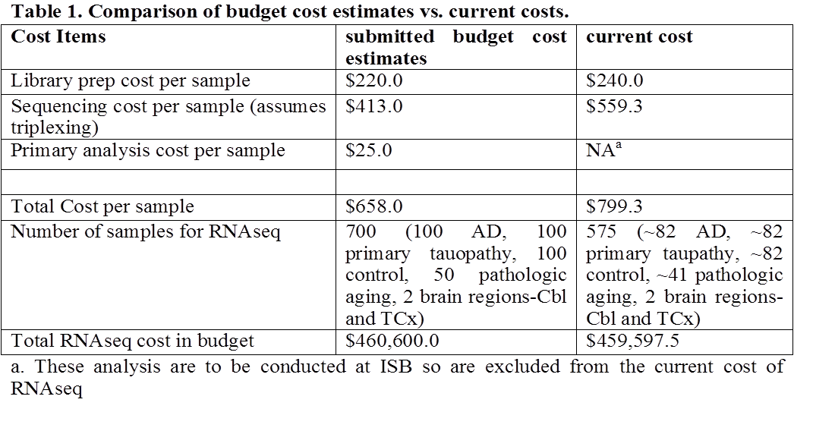

**Table 2** depicts the descriptive statistics for the quality of RNA extracted from 534 brain samples to date, as indicated by RNA Integrity Numbers obtained from Agilent 2100 Bioanalyzers. As seen below, we have successfully completed extractions for all AD and primary tauopathy samples planned not just for Year 1 but also Year 2. Since elderly control and pathologic aging subjects are rare in any one Brain Bank, we contacted Banner Sun Health Institute to obtain additional elderly control and pathologic aging brains. Following the selection process, we identified an additional 51 Cbl and 42 TCx samples from control brains; and 31 pathologic aging brains with tissue from both regions. After completion of the MTA process, we received the brain samples from Banner Sun Health Institute on 6/24/2014. Thus, we have either RNA or brain tissue on ~80% of all target samples from both Year 1+Year 2 Milestones. We completed RNA extraction from control and pathologic aging subjects from Banner Sun Health Institute. Consequently, we currently have RNA from Cbl of 24 and Tcx of 80 control subjects, which is >50% of the year 1+2 goals for this diagnostic category. In addition, we also have 30 RNA samples from pathologic aging subjects. The quality of RNA for all extracted RNA samples is reflected in their RINs which have a median of 7.5-8.5 (mean~7.4-8.5±standard deviation~0.5-1.0), despite being from archived brain tissue generally notorious for yielding low quality RNA.

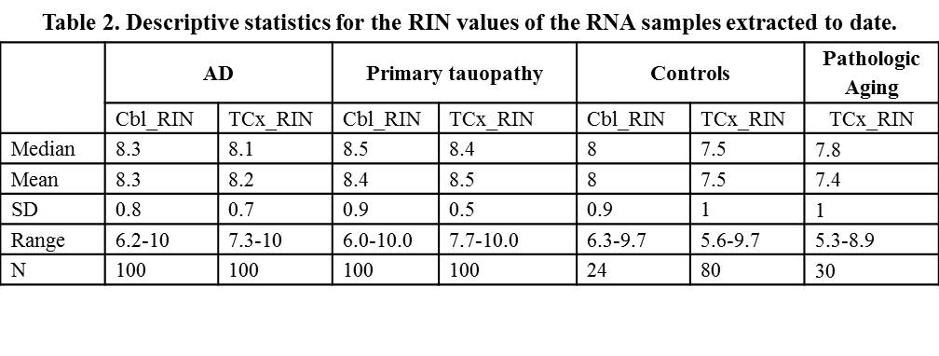

Having completed RNA extractions from the TCx of all pathologic diagnostic categories with available samples, we have performed randomizations to achieve our Year 1 RNAseq cohort of 288 samples. Based on the decision by colleagues at SAGE and the other U01 PIs to include RNA samples from ROS/MAP in the RNAseq pipelines of the other institutions performing this approach, 10 of our 288 samples, were RNA samples from ROS/MAP. Thus, our randomized year 1 RNAseq cohort includes TCx samples from 84 AD, 84 primary tauopathy, 80 elderly control and 30 pathologic aging subjects. The descriptive statistics for the year 1 RNAseq cohort is shown in **Table 3**. The numbers of samples from each diagnostic category and gender, as well as mean RIN, age and Braak stage is shown per sequencing flowcell to highlight the random distribution of the samples according to these key variables.

**Table 3. Descriptive Statistics for the randomized samples for RNAseq. (Includes 10 samples from ROS/MAP for RNA swap)**

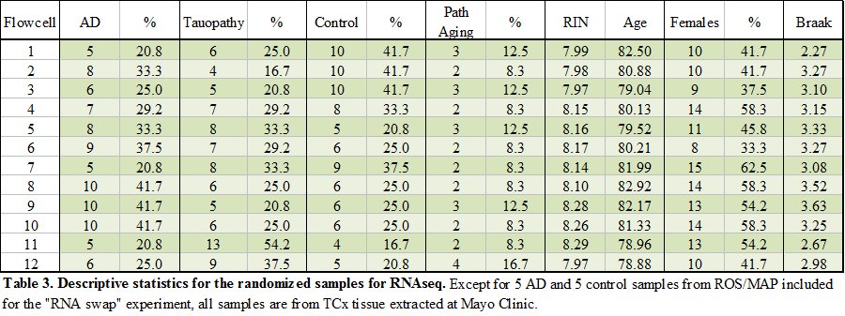

**Milestone 2. Complete initial APP, nTg and tau mouse RNAseq as described in the table below**

**RNA** has been extracted from the mouse samples listed in Table 2. In order to insure adequate numbers we had to breed and age a large number of mice. The samples are now in the queue for sequencing at the Mayo Clinic Genomics core. Samples were extracted using identical methodology to the human brain samples, and all were of high quality. We anticipate sequencing to be complete by the end of September. Thus, we are on Track to deliver this Milestone in year 1 (give or take a month).

**Milestone 3. Begin comparative transcriptomics studies. Gene expression profiling. Initial network perturbation analysis of RNAseq data from humans. Comparative analysis of human and mouse RNAseq data.**

Currently, these samples have started undergoing library preparation at the Mayo Clinic Medical Genome Facility (MGF). The estimated timeline for completion of the RNAseq of these samples, as provided by the Mayo Clinic MGF is 4 weeks for library preparation (expected completion by mid-October) and 5 weeks for sequencing (expected completion by mid-November). While due to delays in the start of our funding as discussed above (activity establishment 11/9/2013), we are behind in Milestones 1 and 3 pertaining to Aim 1 of our grant, we expect to have fulfilled these milestones by the first quarter of Year 2 of this grant. Further, since we have opted to extract all RNA samples to be sequenced in Year 1+2, within this year, we also expect to complete sequencing of the second half of the samples (all Cbl samples) within the second year of the grant.

Regarding generation of a Data Use Certificate (DUC) for sharing of the RNAseq data, we had our first meeting with our colleagues at SAGE and NIA on September 9th where details of the process were discussed. To address the samples from Banner Sun Health Institute (of which 79 are included in the RNAseq experiment in **Table 3**), we provided our colleagues with the MTA and other documents from this institute. Per suggestions of colleagues at SAGE, we are gathering the consent information on the brain samples from the Mayo Clinic Brain Bank, as some of these samples pertain to cohorts that were followed at Mayo Clinic while alive. For this process, we have already engaged study coordinators at Mayo Clinic in Rochester and Florida, the PIs of the relevant studies, Drs. Ronald Petersen and Neill Graff-Radford, and determined the consent numbers for 183 of the 199 Mayo Clinic Brain Bank samples included in **Table 3**. When the IRB approvals, and individual consents are checked for all subjects (we are aiming to get this completed by the first face-to-face meeting at the end of this month), we will work with colleagues at SAGE and NIH to draft a DUC that enables wide-spread sharing of RNAseq data on these subjects in a fashion that is compliant with the IRB and patient wishes.

Finally, we include at the end of report three of our publications from this year which have utilized the brain transcriptome data we previously generated. Though not generated under this U01, we include them in our progress report as they demonstrate the utility of this approach, our contribution to this area and the impact of these studies. We note that two of these studies represent national and international collaborations, which led to the first epigenetic analysis of AD brains and the first genome-wide association interaction analysis of AD, respectively.

Infrastructure for RNAseq data transfer and storage: We are currently investigating and setting up systems to enable efficient transfer of large RNAseq data sets between the Mayo Clinic and ISB. As part of the pilot phase for the NIH AMP-AD Consortium, we have created a UFL-ISB-Mayo partner site on Sage Bionetwork’s Synapse platform to describe, disseminate, and (in some cases) store data from the project (<https://www.synapse.org/#!Synapse:syn2397885/>). We have uploaded existing genotype and eGWAS data from previous studies to the site, and will coordinate with community leads at Sage Bionetworks to make future data generated within the grant available to other members of the consortium (and eventually to qualified public users). Importantly, the Synapse platform is not designed to house very large data sets in raw formats; however, any data stored in the cloud (e.g., Amazon Web Services) can be linked to from Synapse and accessed remotely. To address data transfer needs within the U01 group while also accounting for future needs of interfacing with Synapse and the AMP-AD consortium, we are sorting out the best methods to upload existing and newly generated RNAseq data to cloud storage. In addition to facilitating data sharing within Synapse, our SNAP-RNAseq (SNAPR) analysis program is designed to run remotely using Amazon Elastic Compute Cloud (EC2) instances—thus, cloud storage of the data will greatly reduce time in the analysis pipeline.

Refinement of RNAseq computational analysis pipeline: The SNAPR pipeline has been run on a number of mouse Huntington’s Disease data sets that are similar to the expected AD RNAseq data. Through this process we have identified and fixed minor bugs identified through mapping to the mouse genome. Additionally, the memory footprint for SNAPR has been reduced, enabling us to more efficiently process samples on the EC2 cloud. In preparation for running the mouse RNAseq samples, we have successfully run SNAPR on mouse RNAseq data from other projects. SNAPR generates sorted bam files, identifies potential fusion events and read counts that can be used for calculating differential gene expression.

SAGE Contributions: Sage content for year 1 progress report for AMP-AD consortium. A major goal of this project is to test the feasibility and utility of integrating analyses across projects within and beyond the NIA AMP-AD consortium to make more informed decisions in target identification and validation. This requires significant effort to facilitate the release of data, methodologies, and results in a useable manner and to identify the most lucrative analytical points to leverage resources across the consortium to improve analytical output. To this aim, the team at Sage Bionetworks has developed an NIA AMP-AD consortium workspace using Synapse, a collaborative platform for sharing files and ideas, where consortium members can share analyses. To date, we have developed a private workspace to facilitate sharing across the consortium that is structured to include an individual workspace for each consortium member to share content (e.g., <https://www.synapse.org/#!Synapse:syn2397884>) as well as a broader workspace where collaborative analyses will be performed across the consortium (<https://www.synapse.org/#!Synapse:syn2370594>).  This site is linked to a publicly available workspace where consortium content will be released on a quarterly basis. Sage has trained a bioinformatics lead at each site in how to use this workspace to contribute content and each site has piloted the data contribution process using data described in the preliminary analyses of their grant application so that they are ready to submit grant-funded data as data generation is completed. We are also facilitating the development of consortium-wide collaborative analysis, beginning with a project to perform a cross lab RNA-seq analysis.

Integrated systems approach identifies inflammatory pathway changes in response to IL-10 expression in APP mice (see Chakrabarty et al submitted (attached): We analyzed NanoString nCounter gene expression arrays to investigate expression profiles of RNAs that are altered in the presence of IL-10 in transgenic CRND8 (TG) and non-transgenic (nTG) mice. We first processed and normalized expression data generated using a Neurodegeneration custom array composed of key inflammatory and proteostasis mediators and other known mediators of neurodegenerative pathways. Of the 240 genes tested in this array, we found that 140 genes were significantly differentially expressed (q-value < 0.05) in IL-10/TG mice, and 47 differentially expressed genes (q-value < 0.05) in IL-10/nTG mice compared to genotype-matched controls.

We also used the Ingenuity Pathway Analysis (IPA) tool to identify specific biological pathways that are affected by over-expression of IL-10 in TG and nTG mice. Differentially expressed genes were mapped to canonical pathways in IPA, which highlights individual immune and inflammatory signaling pathways that are most enriched for up- or down-regulated genes in both the TG and nTG mice. Seven of the nine most significantly altered pathways we examined in the TG mice included at least one directly overlapping gene with the IL-10 signaling pathway, supporting a role between IL-10 expression and downstream activation of these pathways.

We further applied the differential rank conservation (DIRAC) method to quantitatively measure how network expression ordering differs within and between phenotypes (Eddy et al., 2010). Using DIRAC, we were able to identify multiple pathways in both TG and nTG mice that were consistently reordered between IL-10 and control cohorts, such that these pathways could be used as statistically significant and accurate molecular classifiers. The motivation of this study was not to develop classifiers; however, gene expression patterns within these pathways that accurately distinguish between IL-10 and control groups provide good measures of confidence for network-level differences. These efforts support a revision of a manuscript currently under review at Neuron.

**Milestone 2. Complete initial APP, nTg and tau mouse RNAseq as described in the table below**

RNAhas been extracted and sent to Mayo for sequencing from: Set 1) JNPL3 tau P301L homozygous and non-TG spinal cords (2, 5, 8+ months) and rTg4510 and non Tg control (forebrain and hippocampus) at 2, 5, and 8 months; and Set 2 which consist of CRND8 (APPTg+/-) APP/PS1 and Non-Tg brains. The samples are now in the queue for sequencing at the Mayo Clinic Genomics core. Samples were extracted using identical methodology to the human brain samples, and all samples were of high quality. We anticipate sequencing to be complete for Set 1 by early October (October 7th) and Set 2 mid-to late November. As soon as possible the mouse RNAseq data will be transferred to ISB and then deposited in SAGE. We recognize the milestone is slightly delayed. However, given the expense of these studies, we felt that waiting to sync the methodology with the human RNAseq samples from Mayo was preferable to rushing them through. There are no consent issues with deposition of these RNAseq data in SAGE, and there will be no restrictions on the DUC for the mouse samples.

**Milestone 4. Launch Phase I Mouse Modeling studies that alter innate immunity in the brain (aims 3 and 4).**

Tables 4 and 5 provide an overview of the cohorts of mice that have been launched under the U01. These establish that we have not only met the milestones outlined but also accelerated some of the studies that were to be begun in year 2. The original milestones were to initiate studies in CRND8 mice on ccl3, cxcl10, ccl4, and M3; these studies are either complete in terms of the cohort being harvested (with analyses pending) or underway with completion expected in year 2. In addition cohorts of sTREM2V5, sTERM2FcV5 and sTLR4, 5 (with and without Fc) were generated. These studies required an additional control group (sFcV5) which has been harvested. Finally reflecting our evolving experience, we are piloting studies with dominant negative (DN) CXCL9 and CXCL10. We believe that conducting biological agonists/antagonist experiments is a very powerful method to validate a target/pathway. We plan to incorporate this design in future studies when feasible but accelerated these studies to provide a potential proof-of-concept. We have also prioritized our analyses of sTLR5FcV5 and appropriate controls (FcV5), as these studies are highly promising and suggest that we *may* be able to nominate TLR5 as a novel target in AD by the end of year 2. Below we provide data that i) describe our findings on sTLR5FcV5 ii) a proof of concept study that demonstrates that the plan for studying disease modification in JNPL3 homozygous mice is also certain to yield informative results and iii) initial data on the behavioral studies in the non-Tg mice.

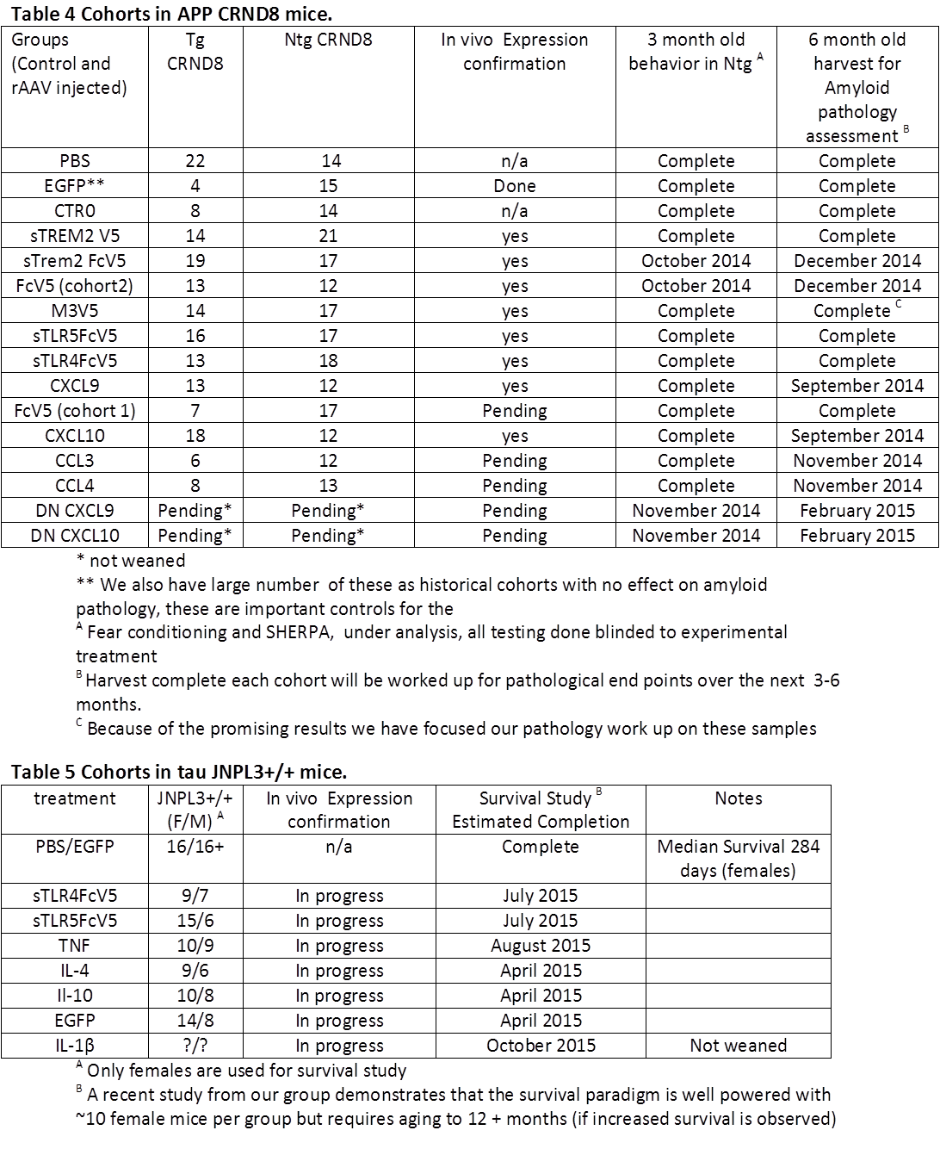

*sTLR5FcV5 studies*. Based on data presented in the original submitted proposal we had preliminary evidence that the rAAV mediated expression of the soluble ectodomain of TLR5 might result in less Aβ deposition in CRND8 mice. Based on this data we launched a second larger cohort of sTLR5V5 and a second cohort of sTLR5FcV5. Initial analysis of a small number of mice by pathology suggested that the sTLR5FcV5 was having a major impact on plaque pathology (~90% reduction by biochemical measures) and we focused our recent studies on the pathological analysis of this cohort and relevant controls. Shown in Figure 1-3 are the current data, based on interim pathological analyses of sTRL5FcV5. These data reveal that 1) sTLR5FcV5 has a major impact on plaque pathology and microgliosis (Figure 1) 2) we can mechanistically link this to sTLR5 binding various forms of Aβ with some preference for aggregates (Figure 2A) 3) that Aβ binds but does not activate the TLR5 receptor and may modulate normal TLR5 signaling (Figure 2B), and 4) sTRL5FcV5 does not alter impairments in FC (Figure 3). Not shown is some initial data (based on a limited group size) where it appears that sTLR5FcV5 also can reduce plaque pathology in mice with preexisting deposits. Hippocampal injection of rAAV2/1-STLR5FcV5 reduced accumulation of insoluble Aβ by ~50% from 9 to 12 months. Finally as noted for Milestone 5 below we have preliminary genotyping data that suggest that TLR5 may have a rare haplotype that is associated with reduced risk of AD.



**Figure 1. rAAV2/1 sTLRFcV5 markedly decreases amyloid pathology and reduces microglial activation.** Studies were from P0 to 6 Months of age. Data shows representative i) Aβ IHC in Cortex and Hippocampus (top left panel) ii) Microglia (Iba-1) and Astrocyte (GFAP) IHC around plaques. Data on right show X-Y plots of Aβ42 and Aβ40 for Control (rAAV2/1-EGFP, rAAv2/1-STLR5FcV5, and rAAV2/1-FcV5. (expression of each protein is verified (not shown). These data show no change in RIPA or SDS but massive reductions in insoluble FA requiring Aβ (~90% reduction, p < 0.001), consistent with IHC result. Note that only a small fraction of Aβ is present in the RIPA and SDS fractions Not all of the cohort has been analyzed IHC data are representative of the subset (n=10 out of 16 analyzed) to date and biochemistry represents 8 of the 16 mice. Completion of these studies is underway. The paucity of reactive glial may be attributable to the large reduction in cored plaques in the sTLR5FcV5 mice.

Behavioral Analysis in Non-Tg Mice. We have as noted in Table 4 collected the data for many of the cohorts proposed for the behavioral analysis for Aim 4. We have done these studies in a blinded fashion and have now begun analysis of the data. An example of the data analyzed is shown in Figure 4. How we pursue suggestive data from these studies will be a matter for discussion with program.



**Figure 2. Recombinant sTRL5FcV5 binds Aβ.** A) Recombinant sTLR5FcV5 was purified from stable CHO lines and bound to Fc biosensors. Once bound to the senor as reflectedby the wavelength shift (nM) the sensor is washed and exposed to ligands. In this case we can note that Aβ oligomers rapidly bind (A arrow, dark blue line). We cannot detect binding of Flagellin (light blue line) in these studies. Other controls (including those not shown) here include FcV which does not bind Aβ in this assy. Following binding the sensor is moved to buffer (B arrow). One can see that there is very slow dissociation of Aβ from the sTLR5FcV5. To confirm binding we can show that the Aβ bound to sTLR5FcV5 can be bound by anti-Aβ1-16 (Ab9) (C arrow), which has a high Kd for Aβ. B) HEK blue cells TLR5 cells were purchased from Invivogen. These cells provide a reporter assay for TLR5 activation based on activation of NFκB promoter driven expression of SEAP. In numerous studies we found no evidence for Aβ in any form signaling through TLR5. Based on binding data we speculated that it may bind but not signal. Therefore we conducted a study to determine if Aβ could alter Falgellin singling through TLR5. The data show that when preincubated various forms of aggregated Aβ attenuate Flagellin induced TLR5 singling, but when added following Flagellin addition actually potentiates signaling.

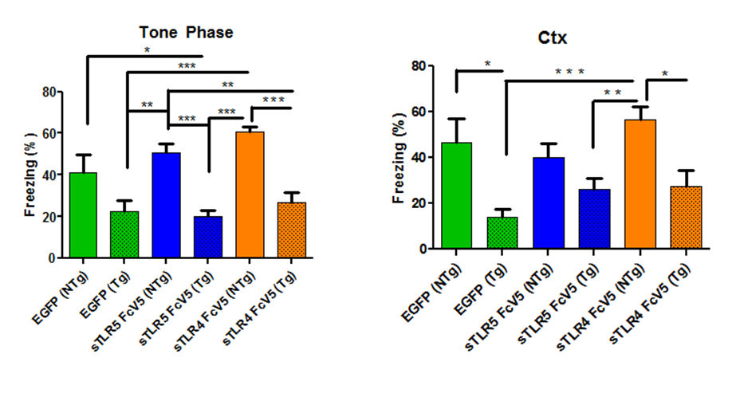

**Figure 3. No Effect on Fear Conditioning memory and learning with expression of TLR5FcV5.** These data show that at 6 months the CRND8 (Tg) mice are impaired relative to littermate controls but hat the expression of sTLR5FcV5 does not significantly improve Fear Conditioning mediated memory and learning despite large effects on amyloid levels. Group sizes are n=9-17.

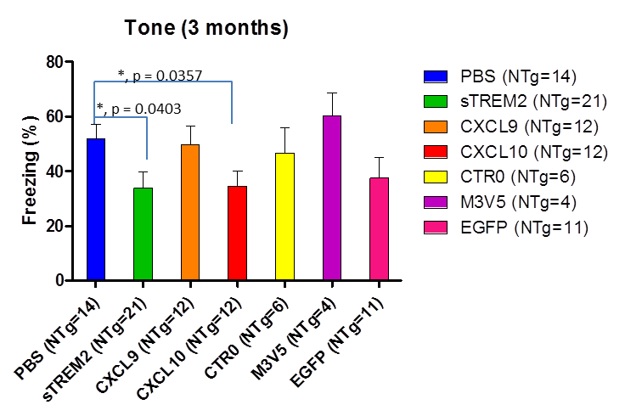

**Figure 4. Initial data from FC studies in 3 month old WT mice expressing the various genes indicated (Tone response is shown)**. Note that the data is analyzed by t-test not corrected for multiple testing suggest that CXCl10 and sTREM2 expression may impair learning and memory.



**Figure 5. Proof of concept that the JNPL3 survival studies are powered to detect changes in survival and detect disease modifying effects**. P0 Homozygous JNPL3 tau P301L +/+ mice were injected with rAAV2/1 encoding anti-tau scFvs(PHF1scFv or CP13scFv) or intrabodies (PHFi or CP13i). Female mice were aged till they became moribund due to motor deficits. N= 16 for controls and 7-8 for the scFvs/intrabodies.

*Tau P301L mouse studies*. Based on historical data we had proposed to screen for disease modifying effects in tau JNPL3 P301L homozygous. However, we had never proven that we could in fact use this paradigm to show disease modification. Indeed, few studies have convincingly shown disease modification in tau mice. We now provide data from studies funded by Bright Focus (Y. Levites PI) that scFvs and intrabodies that target tau can in fact prolong survival in this line (Figure 5).

**Milestone 5. Begin Integrative Genetic Studies. These studies will be ongoing though the life of the grant. They are designed to identify eSNPs and other rare functional variants in candidate immune genes that associate with LOAD.**

Among the functional, disease-associated variants in candidate immune genes, protein-altering variants are particularly important because they can readily be investigated in model systems. The Exome Variant Server (EVS, <http://evs.gs.washington.edu/EVS/>) catalogs whole exome sequencing of 4300 unrelated European Americans, a series large enough to detect virtually all exonic variants with a minor allele frequency (MAF) of 0.1% (1/1000) or more. Thus expensive resequencing is no longer required to discover such variants, and it is now possible to perform a meaningful, low-cost search for “actionable” variants with MAF > 0.1% by genotyping protein-altering variants cataloged on the EVS in large European American case-control series.

In a proof-of-principle study (Medway et al, Molecular Neurodegeneration, 2014) designed to evaluate the utility of this approach, we searched the EVS for novel protein-altering *APOE* variants with MAF > 0.1% and found just two, p.L28P (0.17%) and p.V236E (0.12%) in European Americans. Both were analyzed in our large European American case control series of 4128 LOAD subjects and 4986 non-demented controls. The minor allele of p.L28P, which was in complete linkage disequilibrium (D’=1) with the far more common APOE 4 allele, showed no association with LOAD (P=0.75) independent of the APOE 4 allele. Remarkably, p.V236E was significantly associated with a marked reduction in risk of LOAD (*P*=7.5x10-05; *OR*=0.10, 0.03 to 0.45). The minor allele of p.V236E, which was in complete linkage disequilibrium (D’=1) with the common APOE 3 allele, identifies a novel LOAD-associated haplotype (*APOE* 3b) which is associated with decreased risk of LOAD independent of the more abundant *APOE* ɛ2, ɛ3 and ɛ4 haplotypes. The ApoE p.V236E substitution is the first disease-associated change located in the lipid-binding, C-terminal domain of the protein. Additional follow-up studies are planned and will be important to confirm the significance of this association and to better define its odds ratio.

Given our success in this proof-of-principle study and the promising results on TLR5 obtained by the Golde group, we undertook a similar study to determine whether protein-altering variants in TLR5 and TLR4 cataloged on the EVS show significant association with AD. We are now completing the genotyping of all protein-altering variants with minor allele frequencies of 0.1% or more in TLR4 (n=6) and TLR5 (n=10) (see figure 5 for location of TLR5 variants) in our case-control series. We are also genotyping additional variants with MAF of 0.02%-0.09% in TLR4 (n=6) and TLR5 (n=9) as many of the protein-altering variants in this frequency range are pathogenic as predicted by three independent tools (PolyPhen, SIFT and Provean).

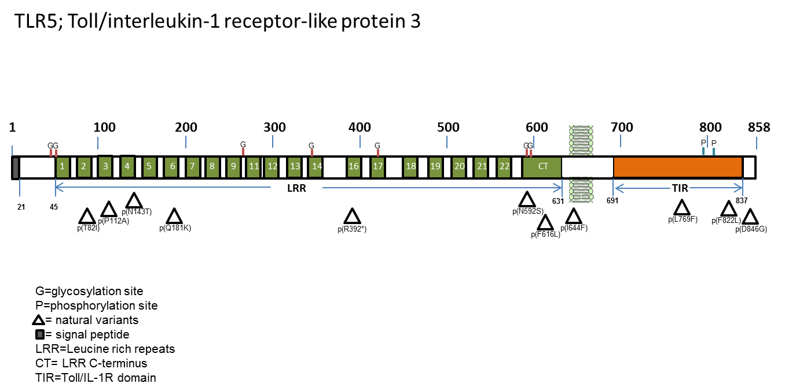

**Figure 5. Schematic of TLR5 and variants analyzed. Variants shown are those with MAF > 1.0%.**

At present, we have genotyped eight TLR4 variants and ten TLR5 variants in over 5000 subjects from our Mayo case-control series. All eighteen occur in our series at frequencies consistent with those posted on the EVS, but only six have minor allele frequencies of 1% or more permitting reasonably well-powered analysis at this point. Table 6 shows the results obtained when these six variants were analyzed by univariate logistic regression using an additive model with series, age, sex, APOE 2 dosage, and APOE 4 dosage as covariates. The one variant in TLR4 (p.D299G) showed no association (OR=1.01, P=0.90), but 2 of the five variants in TLR5 (p.I644F and p.D846G) showed significant association with AD (P=0.013), and a third (p.F616L) showed suggestive association (P=0.084). Figure 5 shows a schematic of TLR5 and the locations of these six variants; the locations of two additional TLR5 missense variants (p.L487I and p.N592S) with MAF of 1.0% or more are also depicted. Both variants are discussed below.

**Table 6. Analysis of Protein Altering TLR4 and TLR5 Variants by Univariate Logistic Regression**



Variants p.I644F and p.D846G invariably occur together. From the 1000 genomes repository and our own genotyping of a third variant (p.L487I) in 739 subjects, it is clear that all three of these variants have frequencies of 1%, are in complete linkage disequilibrium, and create a haplotype (H4 in Table 7 below) which also includes the minor allele of p.F616L. Thus H4 encodes a TLR5 protein that is altered at 4 sites (p.L487I / F616L / I644F / D846G). Variants p.Q181K and p.R392* (stop codon inserted at position R392) also invariably occur together forming a haplotype (H3 in Table 7) that encodes a p.Q181K form of TLR5 that is truncated at position 392. H2 includes only the most common missense variant and therefore encodes TLR5 p.F616L. The most common H1 haplotype has major alleles at all six loci and encodes unmodified TLR5. Thus these 6 TLR5 missense variants with minor allele frequencies of 1% or more create just 4 haplotypes that encode four forms of TLR5. When these haplotypes were analyzed by multivariate logistic regression using an additive model with series age, sex, APOE 2 dosage, and APOE 4 dosage as covariates and H1 as referent (Table 7), they showed significant global association with AD (P=0.0089). This global association was driven primarily by H4. Compared to H1 (which encodes unmodified TLR5), this haplotype (which encodes (p.L487I / F616L / I644F / D846G) was associated with markedly reduced risk of AD (OR=0.52, p=0.0060). H2, which encodes p.F616L, was associated with a suggestive reduction in risk of AD (OR=0.91, P=0.067). Thus our data suggest that the inclusion of three additional missense variants (p.L487I / I644F / D846G) in the protein encoded by H4 may strengthen a protective functional effect that occurs in the p.F616L protein encoded by H2. The H3 TLR5 gene includes the F616L codon, but the protein translated by this gene is a p.Q181K form that is truncated at R392. Our data indicate that this variant may not be associated with altered risk of AD (OR=1.06, p=0.52).

**Table 7. Analyses of Protein-Altering TLR5 Haplotypes by Multivariate Logistic Regression**



It is critically important for us to extend the promising results we have obtained for missense variants in TLR5 in additional case-control series so as to (i) better define effect size by narrowing the 95% CI for each OR and (ii) determine if highly significant results can be obtained that provide a secure basis for functional work on the variant TLR5 proteins. We plan to do this by (i) continuing to genotype our series, (ii) exploring imputed results derived from the large AD GWAS that should now be available to us, and (iii) taking advantage of the ADSP whole exome sequencing now being completed in a large AD case-control series as soon as we are able to gain access. We are currently working on the one remaining TLR5 missense variant (p.N592S) that is common. It is clear that that this variant creates a fifth common haplotype with a frequency of 15-16% that encodes a protein with only p.N592S altered.

The goal of all four groups working within this U01 is to nominate a new therapeutic target(s) for AD. The genetic studies we are undertaking in this aim can be used to validate and to understand virtually any target by identifying and understanding functional genetic variants that affect the target thereby unequivocally altering risk of AD. Most of the supply money for Aim 1 in Year 1 was originally intended for whole exome sequencing (WES). We now believe it is preferable to carry those funds over for use in subsequent years either for WES, as originally proposed, or to pursue alternative methods such as those described above, which may prove to be a more cost-effective way to identify functional variants in candidate immune genes that associate with LOAD. We would welcome face-to-face discussion with the other groups to consider how best to use our combined resources and those that are or will soon be available from outside the consortium so as to maximize the chance of acquiring compelling genetic evidence for candidate target genes that may emerge from any of our studies.

**c. SIGNIFICANCE**

These studies have the potential to identify novel immunological targets that could leverage therapies currently being developed for systemic immune disorders. Furthermore, even if there are not approved therapies or proof of concept studies conducted, large numbers of innate immune pathways are druggable, either with small molecules or biologic agents. In addition, these studies are significant as they will provide important insights into how these various manipulations of innate immune activation states alter normal behaviors with an emphasis on cognition. These data have relevance to AD and age related memory decline as well as other disorders of the brain in which altered innate immune activation states have been implicated. Though this later facet is highly relevant to therapeutic development, it has broad relevance by providing important new information regarding the role of innate immune signaling in controlling behavior. Finally, the studies will be highly significant for the broader AD research community as they will provide a rich transcriptomic dataset of unparalleled scale from human patients with AD, pathological aging and primary tauopathies as well as mouse models of Aβ and tau pathology.

We already have strong preclinical data supporting sTLR5-FC constructs as possible novel AD immunotherapy and are using the infrastructure of this U01 to see if TLR5 can be genetically validated as a risk factor in AD. Notably there is evidence from the literature that variants in Haplotype 4 can influence TLR5 function. Our initial data are encouraging in this regard. Not only do we have a novel target, but we have in a sense proven a way to drug it. Cleary if the genetics is reproducible, we will have met the criteria for most of what is a validated target at least for Aβ. We will await studies in tau models to see the effect in a second AD-relevant model.

Our phenotype in IL-10 mice, which we can in part attribute to APOE expression, is fascinating as it suggests a potential complex relationship between innate immune response and underlying genetic risk factors. As mouse APOE is highly amyloidogenic increasing its expression is clearly not beneficial; however, in humans one might predict that increase of APOE2 would be beneficial whereas effects of increased APOE3 would be harder to predict. In any case, the systems levels approach was instrumental in providing a more complete mechanistic understating of the harmful effect of Il-10.

**D. Plans For Year 2.**

We anticipate little major change in the Milestones for Year 2 with the exception of the balance between genotyping and execution of exome sequencing. In joint discussions with NIH program and ourAMP partners that consider the data from our initial studies, we will jointly determine which is the more cost- and information-effective approach. As noted above there is a slight delay in the RNAseq data, but this should not impede overall deliverables over the course of the grant. The Milestones as noted are:

**Year 2.**

**Milestone 1. Completion of RNAseq studies: Human (2 brain regions TCx Cbl, 82 AD, 82 primary tauopathy, 41 pathologic aging, 82 control subjects); Mouse Set 1) JNPL3 tau P301L homozygous and non-TG spinal cords (2, 5, 8+ months) and rTg4510 and non Tg control (forebrain and hippocampus) at 2, 5, and 8 months; and Set 2 which consist of CRND8 (APPTg+/-) APP/PS1 and Non-Tg brains.**

**Criteria for success:**

* Sequence data generated, evaluated for quality, annotated and analyzed by ISB’s SNAP-RNAseq analysis.

**Rationale:**

* Key step towards completion of Aim 1. Budget was generated to divide the initial human brain sample RNAseq over the first two years. These studies will enable more broad and rational identification of key nodes within the innate immune signaling pathways.

**Milestone 2. Initiate prediction of immune targets most promising and amenable for targeted study to feed back to the experimental studies**

**Criteria for success:**

* Data Analysis near completion through the SNAP-RNAseq pipeline.
* Network perturbation analyses and comparative analyses between the human and mouse.
* Data analysis enables generation of a focused Nanostring array to track key expression changes in mouse models and in human brain.
* Initial prioritization of candidate innate immune targets for both validation studies and Phase II mouse modeling studies.

**Rationale:** Key first steps in the iterative systems levels analysis of the RNAseq data.

**Milestone 3. Complete Phase I Mouse Modeling studies that alter innate immunity in the brain including:**

1. Complete initial pathological analysis of all cohorts established in Tables 4 and 5 above.

**Criteria for success:**

* Primary analysis complete for all cohorts >90% completed with novel findings submitted/in preparation for publication (prioritized based on level of interest).
* sTRL5 data submitted for publication
* RNA available to examine how these manipulations altered innate immune gene expression.

**Rationale:**

* These first phase mouse studies that will enable us to iteratively evaluate how innate, immune modulation alters relevant phenotypes and the effects of these manipulations on the emerging perturbed network model.

**Milestone 4. Continuation of Integrative Genetic Studies.**

**Criteria for success:**

* Completion of eQTL analysis to identify eSNPs that influence levels of transcripts in innate immune pathways.
* Genotyping to test putative functional SNPs in candidate immune genes for association with LOAD. Both eSNPs emerging from Aim 1 and rare SNPs (e.g. missense SNPs) identified by whole exome sequencing and/or data mining will be analyzed.

**Rationale:**

* We have shown that several of the recently described AD SNPs are eSNPs, and we have now identified two relatively rare missense variants in TREM2 that associate with AD. In the past year, we have also obtained preliminary evidence that a TLR5 haplotype containing four missense variants may be associated with AD. Thus, it is reasonable to believe that the proposed analysis of eSNPs and coding variants can be used successfully to show association with AD. Any innate immune gene that is genetically associated with AD provides not only disease insight but also enhances the rationale for targeting that gene.

**Milestone 5. Continue comparative transcriptomics studies. Begin validation of key gene expression changes in innate immune genes.**

**Criteria for success:**

* Completion of gene expression profiling analysis in human brains to identify concerted differences in innate immune pathways.
* Completion of eQTL analysis with a list of eSNPs that influence levels of innate immune pathway transcripts.
* Completion of human vs. mouse gene expression profiling results to identify conserved changes in innate immune pathways.
* Commence validation studies in 600 follow-up brains.
* Commence correlations of transcript level changes with disease pathologies.
* Evidence that the innate immune target is altered at the protein level in human AD/tauopathy brain.
* Cellular and regional localization in the brain.

**Rationale:**

* Prioritization of novel candidate immune targets to align with phase II animal studies. Need to validate GEP changes in order to advance the target to animal modeling studies. Generation of eSNPs to feed into Milestone 4.

**Milestone 6. Launch Phase II animal studies**

**Criteria for success:**

* Generation of rAAV vectors that can modulate prioritized innate immune targets
* Validation of *in vivo* expression and modulation of target in mouse brain
* Staged initiation of APP and tau mouse model studies
* Staged initiation of behavioral studies in non-Tg mice
* Overall longitudinal cohorts for studies for 3+ novel targets underway

**Rationale:**

Key modeling studies to evaluate the effects of manipulating novel targets identified by the systems biology studies.

**E. Publications**

1. Association of MAPT haplotypes with Alzheimer’s disease risk and MAPT brain gene expression levels. Allen M, Kachadoorian M, Quicksall Z, Zou F, Chai H-S, Younkin C, Crook JE, Pankratz VS, Carrasquillo MM, Krishnan S, Nguyen T, Ma L, Malphrus K, Lincoln S, Bisceglio G, Kolbert CP, Jen J, Mukherjee S, Kauwe JK, Crane PK, Haines JL, Mayeux R, Pericak-Vance MA, Farrer LA, Schellenberg GD, ADGC, Parisi JE, Petersen RP, Graff-Radford NR, Dickson DW, Younkin SG, Ertekin-Taner N. Alzheimer’s Research and Therapy, 2014, 6:39.
2. De Jager PL, Srivastava G, Lunnon K, Burgess J, Schalkwyk LC, Yu L, Eaton ML, Keenan BT, Ernst J, McCabe C, Tang A, Raj T, Replogle J, Brodeur W, Gabriel S, Chai HS, Younkin C, Younkin SG, Zou F, Szyf M, Epstein CB, Schneider JA, Bernstein BE, Meissner A, Ertekin-Taner N, Chibnik LB, Kellis M, Mill J, Bennett DA. Nat Neurosci. 2014 Sep;17(9):1156-63. PMID: 25129075.
3. Gusareva ES, Carrasquillo MM, Bellenguez C, Cuyvers E, Colon S, Graff-Radford NR, Petersen RC, Dickson DW, Mahachie John JM, Bessonov K, Van Broeckhoven C; the GERAD1 Consortium, Harold D, Williams J, Amouyel P, Sleegers K, Ertekin-Taner N, Lambert JC, Van Steen K. Neurobiol Aging. 2014: S0197-4580(14)00377-7. PMID: 24958192.
4. Chakrabarty P *, Li A, Ceballos-Diaz C, Eddy JA, Funk CC, Moore B, Rosario AM, Verbeeck C, Sacino A, Nix S, Janus C, Price ND, Das P and TE Golde*. IL-10 Alters Immunoproteostasis in APP mice, increasing plaque burden and worsening Cognitive Behavior. Resubmitted to Neuron. June 2014 (currently in discussion with editors on fate).